BBioNets Driving EU Bioeconomy Policy: From National Evidence to High-Level Strategy and Capacity Building
  - FOR IMMEDIATE RELEASE
  - XX June 2026
The EU-funded BBioNets project is spearheading a synchronised effort to reshape European rural policy and accelerate circular bioeconomy innovation, moving seamlessly from grassroots mobilisation to high-level European strategy.
In the first half of 2026, BBioNets conducted targeted national policy events across its six partner countries (Ireland, Greece, Poland, Czech Republic, Spain, and Italy). The valuable findings from these regional workshops directly paved the way for a major EU-level policy event in Brussels on 27 May 2026. To bring this event to life, BBioNets leveraged its Standing Liaison Round Table (SLRT) initiative which brings together 20 bioeconomy-related projects. As the initiator, BBioNets coordinated with the network, leading to six fellow SLRT projects joining forces to co-organise the event and present their collective policy findings.
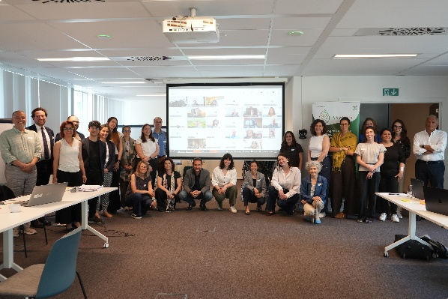
Operating as a dynamic "Policy Lab," this joint effort united BBioNets, Soil-X-Change, AQUAGRI-KNOW, BRILIAN, C4B, Rural BioReFarmeries, and SOUL. The collaborative gathering focused on translating technical data and regional realities into concrete policy recommendations aligned with the new European Bioeconomy Strategy. Key discussions centred on synthesising multi-project evidence on sustainable resource management, fostering direct dialogue between local practitioners and EU decision-makers, and navigating complex EU regulations to analyse their direct impact on bioeconomy stakeholders and future growth.
Following an institutional keynote from the EU CAP Network Support Facility, the event featured parallel working groups focused on natural resource management and regulatory frameworks. The day concluded with a Multi-Actor Roundtable where participants debated these findings, with the finalised recommendations to be published in the coming weeks.
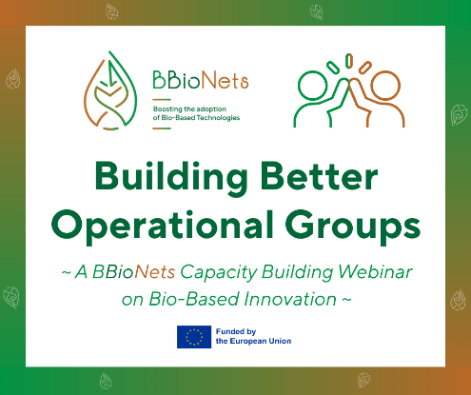
As a direct continuation of this momentum, BBioNets is shifting its focus to practical, on-the-ground implementation, building upon the extensive knowledge transfer activities carried out by project partners in their respective countries over the past year. This practical push centres on a dedicated capacity-building webinar scheduled for 16 June 2026 at 10:30 CET, which directly addresses why Bio-Based Technology (BBT) Operational Groups (OGs) remain underutilised across Europe. To equip National CAP Networks and Managing Authorities for their evolving roles under the post-2027 CAP framework, the project carried out a targeted survey across its six partner countries to map regional needs, systemic bottlenecks, and successful national support mechanisms.
Survey insights will anchor the webinar and drive the introduction of a brand-new Strategic Support Tool for Capacity Building. Designed to complement existing EU CAP Network structures, this tool will help national and regional administrations align practical solutions with the OG creation lifecycle, share peer-tested good practices, and streamline coordination under evolving policy priorities.
To explore the detailed articles on these initiatives or to secure your spot for the upcoming webinar, visit the project website via the links below:
- Read the full article on the Policy Lab event: Co-Creating Policy Recommendations for a Rural Bioeconomy - Full Article
- Read the full webinar announcement and register: Building Better Operational Groups Webinar - Full Article & Registration

Contact details
Name Surname, Position, Organisation, E: xxx@xxxxxx.xxx

Project contact details
Carmen Girón Domínguez, Project coordinator, Munster Technological University, E.: Carmen.Dominguez@mtu.ie
Dafni Delioglani, Dissemination & Communication manager, FOCUS Strategic Thinking Consultants, E.: dafni.delioglani@focus-stc.gr
Learn more about BBioNets on our website & social media! |  |  |  |  |  |  | www.bbionets.eu
 | /bbionets-eu |  |  | /bbionets.eu |  |  | @bbionets_eu
 | @bbionets-eu.bsky.social |  |  | @bbionets_eu |  |  | @BBioNetsEU

Document information
Title | BBioNets – Creation and promotion of Forest and Agriculture Networks to boost Bio-Based Technologies adoption and Value Chain development (GA No 101133904)
Start – end date | 1/11/2023 – 31/10/2026 (36 months)
Project type | Coordination and Support Action
Programme | Horizon Europe – Cluster 6
Funding | 1,998,636.20 €
Coordinator | Munster Technological University  Ms. Carmen Girón Domínguez  (carmen.dominguez@mtu.ie)
Project overview | BBioNets constitutes a thematic network that relies on, promotes, and further advances the work carried out by EIP-AGRI Operational Groups (OGs) with respect to management and/or processing of agricultural and forest biomass with Bio-Based Technologies (BBTs). The project has set up 6 regional Forest and Agriculture Networks – FANs (IE, ES, IT, EL, PL, CZ) that identify local needs, prioritise specific BBTs and share BBT knowledge ready for practice to farmers and foresters, boosting the (re)definition of value chains, stimulating cross-fertilisation beyond borders, and bringing Europe to the forefront of farming, forestry and bioeconomy with economically viable and sustainable practices.
Consortium | 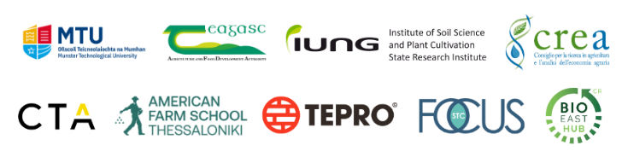

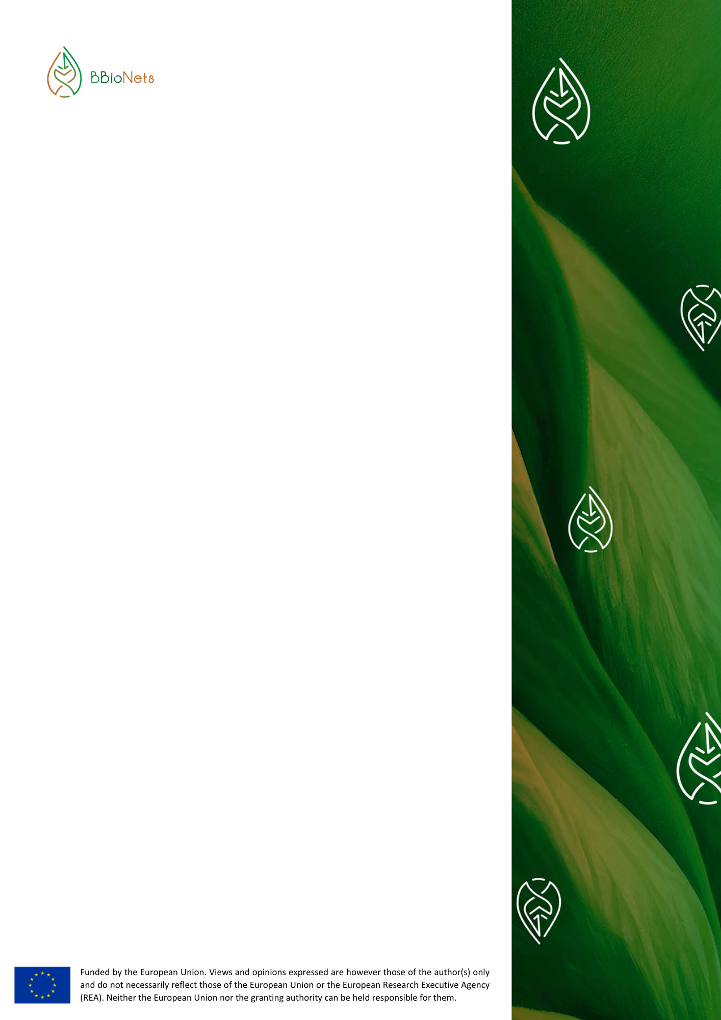
@bbionets-eu.bsky.social
info@bbionets.eu
/bbionets-eu
/bbionets.eu
@bbionets_eu
@bbionets_eu
@BBioNetsEU
www.bbionets.eu
info@bbionets.eu
@BBioNetsEU
@bbionets_eu
@bbionets-eu
@bbionets_eu
@bbionets.eu

